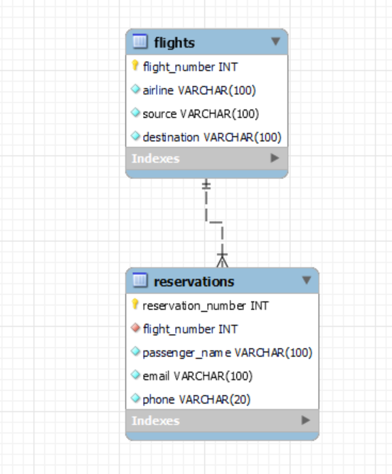

CREATE DATABASE flight_reservation;

USE flight_reservation;

-- Create the 'flights' table

CREATE TABLE flights (

flight_number INT PRIMARY KEY,

airline VARCHAR(100) NOT NULL,

source VARCHAR(100) NOT NULL,

destination VARCHAR(100) NOT NULL

);

-- Create the 'reservations' table

CREATE TABLE reservations (

reservation_number INT AUTO_INCREMENT PRIMARY KEY,

flight_number INT NOT NULL,

passenger_name VARCHAR(100) NOT NULL,

email VARCHAR(100) NOT NULL,

phone VARCHAR(20) NOT NULL,

FOREIGN KEY (flight_number) REFERENCES flights(flight_number)

);

INSERT INTO flights (flight_number, airline, source, destination) VALUES

(1001, 'Delta Airlines', 'New York', 'Los Angeles'),

(1002, 'American Airlines', 'Chicago', 'Miami'),

(1003, 'Southwest Airlines', 'Dallas', 'Houston'),

(1004, 'United Airlines', 'San Francisco', 'Seattle'),

(1005, 'JetBlue', 'Boston', 'Orlando'),

(1006, 'Spirit Airlines', 'Las Vegas', 'Denver'),

(1007, 'Alaska Airlines', 'Portland', 'Anchorage'),

(1008, 'Frontier Airlines', 'San Diego', 'Phoenix'),

(1009, 'Hawaiian Airlines', 'Honolulu', 'Maui'),

(1010, 'Allegiant Air', 'Nashville', 'Tampa');

INSERT INTO reservations (flight_number, passenger_name, email, phone) VALUES

(1001, 'John Doe', 'john.doe@example.com', '123-456-7890'),

(1002, 'Jane Smith', 'jane.smith@example.com', '234-567-8901'),

(1003, 'Alice Johnson', 'alice.johnson@example.com', '345-678-9012'),

(1004, 'Bob Brown', 'bob.brown@example.com', '456-789-0123'),

(1005, 'Carol White', 'carol.white@example.com', '567-890-1234'),

(1006, 'David Green', 'david.green@example.com', '678-901-2345'),

(1007, 'Emma Black', 'emma.black@example.com', '789-012-3456'),

(1008, 'Frank Lee', 'frank.lee@example.com', '890-123-4567'),

(1009, 'Grace Kim', 'grace.kim@example.com', '901-234-5678'),

(1010, 'Hank Wilson', 'hank.wilson@example.com', '012-345-6789');

select * from flights;

select * from reservations;

